# OO Programming Fundamentals

# Practical Week 4 – 6th October 2014

Create a **Practical Week 4** folder in your **Java folder** on your **G** drive

**G:\Java\Practical Week 4**

* Save all the following exercises into the **Practical 4** folder

#### Exercise 1

Enter Program from notes - **If statement** to determine what to wear depending on the weather being good.

# Create project in Practical Week 4 folder as: ex4a

**Sample Output:**

# 

OR

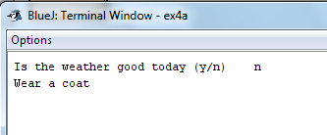

# Exercise 2

Write a program which asks the user to enter their Salary.

* If their salary is greater than or equal to 30,000 print a message to say they must pay 42% tax.
* If their salary is under 30,000 print a message to say they must pay 26% tax.

Enter Program from Moodle Notes.

# Create project in Practical Week 4 folder as: ex4b

**Sample Output**

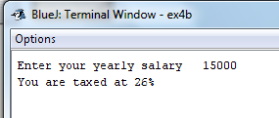

**Or**

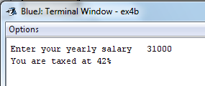

# Exercise 3

Write a program which asks a waiter the cost of a customer’s meal. If the cost of the meal is €10 or more, calculate a 5% discount on the bill and print the new value of the bill to the screen, otherwise give a message saying no discount.

# Create project in Practical Week 4 folder as: ex4c

**Sample Output:**

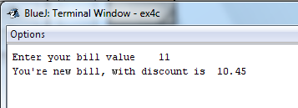

**or**

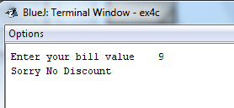

**Exercise 4**

A senior salesperson is paid £400 a week and a junior salesperson £290 a week. Write a program that accepts as input a salesperson's status in the integer variable **status.** If status equals 1 the senior salespersons salary should be displayed. Otherwise the junior salespersons salary should be displayed.

# Create project in Practical Week 4 folder as: ex4d

**Sample Output**

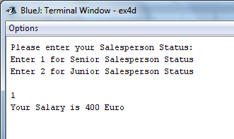

**Or**

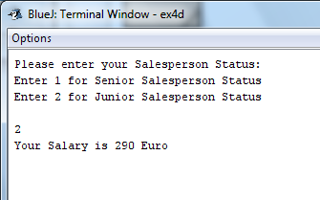

**Exercise 5**

Write a program to read any 2 integer values and store them in variables x and y. Write the code to determine which value is greater than the other and print one of the messages: x is the larger value or y is the larger value.

# Create project in Practical Week 4 folder as: ex4e

**Sample Output:**

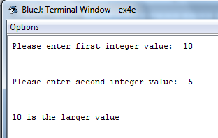

OR

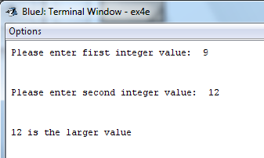

**Exercise 6**

Write a program to read an integer value from the keyboard and print one of the following messages: “*Multiple of three”* or “N*ot multiple of three”.*

**Use the Modulus Operator:**

If the value entered by the user, when divided by 3, has no remainder then the value is a multiple of 3.

else

If the value entered by the user, when divided by 3, has a remainder then the value is not a multiple of 3.

(integer value entered % 3 == 0)

# Create project in Practical Week 4 folder as: ex4f

**Sample Output:**

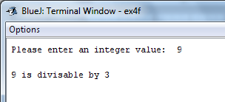

**OR**

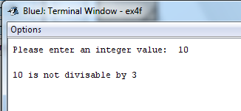

**Completing this weeks’ Practical:**

* When you submit work, you will send it in zip file format.
* To create a zip file of your practical work:
  + In Windows Explorer, right click on the **Practical Week 4** folder that contains your work.
  + When the context menu appears, choose the **Send to** option, followed by the **Compressed (zipped) folder**.
  + This will create a new file called **Practical Week 4.zip** in your current folder
* Note: If you are using your own laptop, you can choose to install very good (and free) compression software called 7zip. Just search for it in Google and download it.

**\*\*\* It is this zipped file that you will upload into Moodle.\*\*\***